Name: ______________________________ Pd: _____ Ast: _____

Chemical Reactions Lab

Introduction: When substances undergo chemical changes they become different substances with different properties because their chemical bonds have changed. Chemical changes are often accompanied by the following:

- Temperature changes (sudden heating or cooling)
- Color change
- Bubbles (sign of gas formation)
- Flame/Light
- Precipitate (solid particles that form when two solutions are combined)

When the reactants calcium chloride, baking soda, and phenol red solution are combined, a chemical reaction takes place as evidenced by heat given off, a change in color, and the production of bubbles (gas). In this investigation you will attempt to determine which reactants are responsible for each of these signs of a chemical reaction.

Your Task: Perform an investigation to determine which reactants are responsible for the heat produced, the color change to yellow, and the production of gas bubbles. (You should also determine which reactants are NOT necessary for each.)

The guiding questions of this investigation are: Which reactants are responsible for causing the heat? Which reactants are responsible for the yellow color change? Which reactants are responsible for the gas formation?

Materials: You will use the following materials during your investigation.
- Plastic Bags  - Small Vial (for wet reactants)  - Scoops (for dry reactants)  - Water  - Phenol Red Solution (phenol red and water) | - Baking Soda (“two scoops” per trial)  - Calcium Chloride (“two scoops” per trial)  - Safety Goggles  - Safety Apron

Safety Precautions:
- Wear safety goggles and a safety apron at all times.
- Never directly smell the chemicals – use wafting instead.
- Never taste or directly touch the chemicals with your skin – use tools and containers when handling the chemicals. You can feel the reaction through the bag.
- Keep expanding bags away from your face. Open the bag over the sink pointing away from you to release the gas.
- Clean up all spills promptly to avoid slips and falls. All reactants and products are non-toxic.

Getting Started:
- The original chemical reaction actually had four reactants. The phenol red solution is a mixture of phenol red powder and water. For your testing you may evaluate the following reactants:
  - 10 g Calcium Chloride (two scoops)
  - 10 g Baking Soda (two scoops)
  - 10 mL Phenol Red Solution (Phenol red powder + water)
  - 10 mL Water
- Use your sense of sight, hearing, touch (through the bag only), and smell (wafting) to make observations.
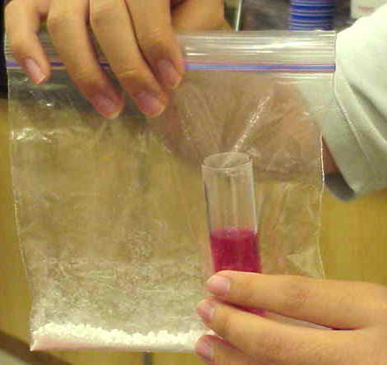
- A method for combining reactants:
  - Place the dry chemical(s) into the bag on opposite corners.
  - Place the proper amount of the liquid chemical(s) into a small vial.
  - Carefully lower the vial into the bag without spilling it contents (this usually takes some teamwork).
  - Seal the bag, tip the contents of the beaker or film canister onto the substance at the bottom of the baggie and mix it all together with your fingers.
  - Observe the changes that take place.
- Complete the items on the back of this sheet as you work through this investigation.

Chemical Reactions Lab Sheet
- DATA
  - Describe each of the reactants below:
    - Water – clear liquid, room temperature
    - Phenol Red Solution – red liquid, room temperature
    - Calcium Chloride – small, solid, white pellets, room temperature
    - Baking Soda – fine white solid powder, room temperature
  - Fill in an “X” in the boxes on the table where applicable to your observations during the lab.
Trial | Reactants | Temperature Change |  | Color Change |  | Gas  Produced | Was it a chemical reaction?
 |  | HOT | COLD | YELLOW | PINK
1 | BS + CC |  |  |  |  |  | NO
2 | W + BS |  | ? |  |  |  | NO
3 | PR + BS |  | ? |  | X |  | NO
4 | W + CC | X |  |  |  |  | YES
5 | PR + CC | X |  |  | X |  | YES
6 | W + BS + CC | X |  |  |  | X | YES
7 | PR + BS + CC | X |  | X |  | X | YES

- HEAT
- Which reactants give off heat when they are mixed? Calcium chloride and water

- What evidence do you have that these are the reactants responsible? In every trial where heat is observed, these are the common reactants

- COLOR
- Which reactants cause a color change when they are mixed? Phenol red solution, baking soda, & calcium chloride.
- What evidence do you have that these are the reactants responsible? These reactants are present in the only trial that resulted in a yellow color change.

- GAS
- Which reactants produce a gas when they are mixed? Water, baking soda, & calcium chloride

- What evidence do you have that these are the reactants responsible? These reactants are present when gas is produced; since trial 6 produced gas, we can conclude that the phenol red did not contribute to the gas formation in trial 7.

- CHEMICAL REACTIONS
- What evidence do we have that a chemical reaction occurred in the bag when all of the reactants were mixed? Color change, temperature change, and gas formation are all indications that a chemical reaction has occurred. We observed all of these signs when we mixed all of the reactants.

- How do the reactants (the things present before the reaction) compare to the products (the things present after the reaction) when all of the reactants are mixed? The products are a different substance than the reactants we started with. They have a different color, a different texture, and even a different physical state.

- Once you put all of the reactants in the bag and sealed it, were any atoms added to the system? Were any atoms removed from the system? What does this mean about the reactants and products of this reaction? No atoms were added to or removed from the bag after it was sealed. This means that the atoms that made the reactants are the same atoms that make the products according to the law of conservation of mass

