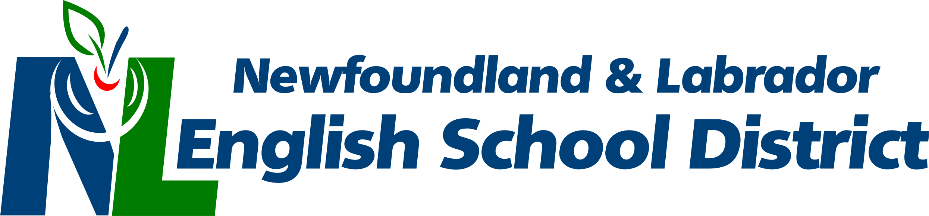
Labrador Regional Office
P.O. Box 1810, Station B
Happy Valley-Goose Bay, NL A0P 1E0
Tel: (709) 896-2431 Fax: (709) 896-9638
_____________________________________________________________________________________

As we look forward to the 2017/18 school year, there are a few points for those who use the School Bus Transportation system to remember.
Responsibilities of Parents and Guardians:
- Ensure the safety and supervision of children prior to pick-up and immediately after leaving the bus on their return trip home.
- Ensure that children are at the proper pick-up location five minutes prior to scheduled pick-up time.
- Impress upon children the need for safe and appropriate behavior while boarding, riding and leaving the bus.
- Ensure that kindergarten students are met by responsible adults at the designated bus stop. Should no one be at the designated bus stop, the child will be returned to school and the parents/guardians must then make alternate arrangements to have the child picked up.
Responsibilities of the Student:
- Arrive at the bus stop five minutes prior to bus arrival time.
- Follow the drivers’ instructions at all times.
- Remain seated at all times to and from school.
- Due to severe allergies, do not consume food or beverages on the bus.
Responsibilities of the Bus Driver:
- Transport students safely to and from school.
- Ensure that the bus and all safety equipment are in good working order.
- Check and walk through the bus at the end of every run.
- Ensure unauthorized persons are not transported on the bus.
The school district may, upon review of loads, scheduling and routing, change the location of bus stops. The school bus driver is a member of the school system and he\she is entitled to the respect and courtesy due all school personnel.
A full list of responsibilities for all who use the School Bus Transportation system can be found at www.nlesd.ca.

